Smart Transportation Formal analysis and definition

Basil Skaria Siddharth S
S4 CSE S4 CSE
Muthoot institute of technology and science Muthoot institute of technology and science
Puthencruz Puthencruz

Eldhose K A Georgy M Rajan
S4 CSE S4 CSE
Muthoot institute of technology and science Muthoot institute of technology and science
Puthencruz Puthencruz

Abstract
Traffic congestion is one of the major concerns in transportation sector. Increasing at a high pace, solutions and suggestions are introduced claiming lighter differences. Productive changes in infrastructure of the modes of transport or any other related factors would currently have to develope at higher pace than that of the traffic. A focus on finding a way to change the mindset of the users and creating awareness about the ill effects instead of infrastructural developement is expected. The defined system analyses the situation over a cloud based server, with web-app interface, provides the solution as result.

Key words: Traffic congestion, PIEV,

1) Introduction

Definition 1: Transport: to take or carry people or goods from one place to another by means of a road vehicle, rails, aircraft, or ship.
Definition 2: Traffic is the collection of vehicles moving on a public highway.
Definition 3: Traffic jam, a queue of stationary or very slow-moving traffic, caused by roadworks, an accident, or heavy congestion.

1.1) Factors causing Traffic jam
This is a set causes of traffic jam in any given road system.
1 Human Factors
- Variability
- Critical Factors
- Quantifiable: reaction time, visual acuity etc.
- Non_Quantifiable: psychological factors, physical strength, fatigue and dexterity.
2 Vehicular factors
- Design of Vehicle
- Dimensions of the vehicle
- Turning radius and path
3 Road factors
- Accidents
- Construction
- Obstructions
- Night visibility
- Geometric Constraints

Definition 4: Road user is subjected to a series of stimuli both expected and unexpected. The time taken to perform an action according to the stimulus is Reaction time.

Factors affecting reaction time:
• Perception: Perception is the process of perceiving the sensations received through the sense organs, nerves and brains. It is actually the recognitions that a stimulus on which a reaction is to happen exists.
• Intellection: Intellection involves the identification and understanding of stimuli.
• Emotion: This stage involves the judgment of the appropriate response to be made on the stimuli like to stop, pass, move laterally etc.
• Volition: Volition is the execution of the decision which is the result of a physical actions of the driver.

These factors form the PIEV time which collectively retrieves the time of total response.

Definition 5: Visual acuity is the clarity of vision, the sharpness or keenness of thought, vision, or hearing of the road user.
Definition 6: Walk is to move at a regular pace by lifting and setting down each foot in turn, never having both feet off the ground at once.
Definition 7: Accidents are an unfortunate incident that happens unexpectedly and unintentionally, typically resulting in damage or injury.
Definition 8: Obstructions is a thing that impedes or prevents passage or progress; an obstacle or blockage.

1.3) Summary of the factors causing traffic jam

The performance, design and operation of a transportation system is affected by several factors such as human factors, vehicle factors, acceleration characteristics, braking performance etc. These factors greatly influence the geometric design as well as design of control facilities. Variant nature of the driver, vehicle, and roadway characteristics should be given importance for the smooth, safe, and efficient performance of traffic in the road.

2) Working Principle:
2.1 Implementation
At.&t (Avoid traffic. And travel) is a platform that provides the user suggestions with the live traffic feeds is accordance to the source to destination path.
Definition 9: At.&t : For a given source and destination, a set of break points exists, at which traffic density is mapped. An alert system at background suggests the use of mode of transport. At road level the congestion is reduced.
Proof:
Consider a scenario where in which a set ‘A’ of ‘n’ transport (vehicles) with variation of ‘d(n)’ through a lane and any of the factors (refer 1.1) is incident on the subset of transport ‘sub(A)’. A congestion of probabilty ‘X’ exsts, where ‘X is directly proportional to n’ for ‘n’ is a time depend variable (i.e. with time new vehicle may queue up -or- the vehicles first to enter may move out at a rate of ‘d(n)’ ).
Let ‘d(n)’ tends be a constant.

2.2 Structure
Database Structural Schema
The Database structural schema of At.&T App contains three tables which stores information regarding the Administrators(The Officials who implements the App),Customers and the Vehicles (containing the IoT module).The Detailed information regarding the Tables are as follows:-

Table 1
Table Name : - AdminTable
Attributes : -
Aid : The Administrator Id. It is Unique and the primary key of the table AdminTable.
Aname : The Administrator Username. It should be UNIQUE and NOT NULL.
Apassword : The Administrator password. It is a character array of size 8.
Table 2
Table Name :- CustomerTable
Attributes : -
Cid : The Customer Id. It is Unique and the primary key of the table.
Cname : The Customer username. It should be UNIQUE and NOT NULL.
Cpassword : The Customer password. It is a character array of size 8.
CFname : The Customer First Name. It should be a character array of size 128.
CLname : The Customer Last Name. It should be a character array of size 128.
CLocation : The Customer’s Location. It should be a character array of size 32.
Csubscription : The Value to indicate if the Customer is using only free advices or he/she is a member who have purchased the IoT module for the Vehicle. It is of type Boolean and 0 indicates Free Member and 1 indicates Paid Member.
Table 3
Table Name :- VehicleTable
Attributes : -
VehicleNo : The VehicleNo attribute store the number of the Vehicle issued by the Motor Vehicle department. It is UNIQUE and primary Key of table VehicleTable.
CustID : The CustID store the customer id number of the customer using the vehicle. It is a Foreign Key and is NOT NULL.
VehicleType : The Vehicle type indicates the kind of vehicle(2 Wheeler,4 Wheeler,etc…). It is NOT NULL.

Relational model of the Database
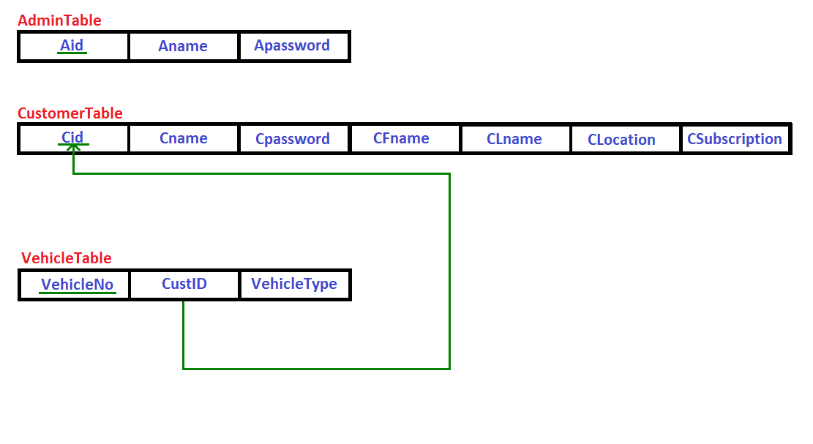

References:

[1] https://nptel.ac.in/courses/105101087/downloads/Lec-4.pdf

